(Date)
The Managing Director/Chief Executive Officer
[Company Name]
Dear Sir/Madam,
MANDATORY INSURANCE COVER - GROUP LIFE ASSURANCE
We have the pleasure to introduce Fortis Global Insurance PLC to your esteemed organization; we are a composite licensed Insurance Underwriting Company and are desirous of being a financial partner to our good-selves in providing insurance services as mandated by the Law and/or required for business operations against the loss of assets and exposure to liability thereof.
Whilst we offer a range of various insurance solutions to cover losses that may arise from business operational activities such Motor Insurance, Plant All Risks Insurance, Fire & Special Perils Insurance, Burglary & Housebreaking, we also more importantly provide Insurance Covers that have been made mandatory by Nigerian Law and Legal Statues.
We therefore wish to draw to your attention that by the provisions of the recently enacted Nigeria Insurance Industry Reform Act (NIIRA) 2025 and Section 4(5) and 8 of the Pension Reform Act 2014, it is now mandated by Law in Nigeria for every employer (SMEs inclusive) with three (3) or more employees to maintain a Group Life Assurance to that would provide financial support to the beneficiary of deceased staff regardless of the cause of death.
Furthermore, the earlier referenced Acts mandated that a minimum cover of three times (3x) the annual emolument (basic salary, housing and transportation allowances) of every staff should be maintained with an insurance company.
We at Fortis Global Insurance PLC, kindly request you’re the indulgence of your organization to provide us with a schedule of all the staff in your employment with their respective emolument to enable us provide you with our terms our Group Life Assurance cover terms.

We are counting on your business patronage and look forward to receiving your response soon.

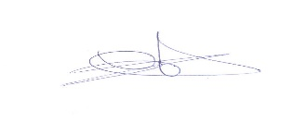
Yours faithfully,
For: Fortis Global Insurance PLC
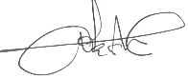
Abiola Ayinla Samuel Ohonusi
Regional Sales Coordinator Group Head, Technical

